IOT Device for Child Safety and Tracking

***Abstract: Child safety and tracking is a major concern as the more number of crimes on children are reported nowadays. With this motivation, a smart IoT device for child safety and tracking is developed to help the parents to locate and monitor their children. The system is developed using Link It ONE board programmed in embedded C and interfaced with temperature, heartbeat, touch sensors and also GPS, GSM & digital camera modules. The novelty of the work is that the system automatically alerts the parent/caretaker by sending SMS, when immediate attention is required for the child during emergency. The parameters such as touch, temperature &heartbeat of the child are used for parametric analysis and results are plotted for the same. The above system ensures the safety and tracking of children.***

## INTRODUCTION

Internet of Things (IoT) plays a major role in every day to day life. The major difference between IoT and embedded system is that a dedicated protocol/software is embedded in the chip in case of embedded system, whereas, IoT devices are smart devices, which are able to take decisions by sensing the environment around the device. The development of sensors technology, availability of internet connected devices; data analysis algorithms make IoT devices to act smart in emergency situations without human interventions. So, IoT devices are applied in different fields such as agriculture, medical, industrial, security and communication applications[1]. IoT systems are useful within a system to do deeper automation, analysis, and integration. IoT contributes to technology by advances in software, hardware and modern tools. It even uses existing and upcoming technology in the fields of sensing, networking and robotics. IoT brings global changes by its advanced elements in the social, economic, and political impact of the users.

Child and women safety is a challenging problem nowadays due to antisocial elements in the society. The crime rate is day by day increasing. Schools and working places need high surveillance for ensuring the safety among children and women. Smart phones are playing major role for ensuring the safety, where some mobile based applications provide alert systems. During the emergency, mobile apps alert the control room of nearby police station or caretakers of children. The literature shows that location tracking devices are available in the market, but it does not provide the complete solution to the problem. The solution to this problem is to design an IoT device, which senses the child’s location and environment and during emergency, it should send the alert to the parents automatically.

## BACKGROUND

The review of literature for child safety and location tracking devices are discussed below. In [2], the parent can send a message to the GSM module, according to the message information the GSM module reply back with particular details of the children. The location can be seen on the Google map. When a particular child is facing an emergency situation, device button should be pressed so that the device captures the image along with the user information to the enrolled mobile numbers. The life of the child can be saved within no time. In [3], for the children point of view GPS, GPRS and GSM are used to monitor the speed and location tracking purpose. The system is fixed on the bus or car or in any vehicle so that the vehicle is going on routine route or not can be identified by the GPS tracker, the speed of the bus can also be extracted. Now-a-days the digital technology plays a major role for connecting persons via internet. For tracking the children, the android based solution is provided to parents. Internet is the one that will connects different components through a single device and is connected to server. Parents track their children in real time of the location tracker by GSM and [4] the microcontroller used is ARM-7 LPC2148. In day to day scenario, missing child cases are increasing gradually. Child caring is a major issue. Different types of methods are introduced to find good solutions. There have been many Methods and systems implemented to solve it. In [5],to solve child caring problem global position system (GPS) based solution with two nodes was proposed. In these two nodes, one node is child node which contains a Bluetooth module and a GPS receiver. The parent node consists of a mobile that supports Bluetooth. The location of the child can be tracked by the GPS

technology and can be

displayed on the designed

map in the mobile device, through the Bluetooth connection the distance between the child and parent can be calculated. Children below six years can not explain in words directly to their parents about the problems, hence a wearable device is developed in [6]. This device procures information such as heart rate, physical body movements and send it to the parents in real time. In [7], a wearable sensor badge is constructed from (hard) electronic components, which can sense perambulatory activities for context awareness. A wearable sensor jacket is used with latest techniques to form (soft) fabric. Stretch sensors are placed to measure upper limb and body movement. Worn as clothing, the sensors give the required information.[7].

In paper[8], wearable IoT device for the security and

shielding of women and girl children was designed. The body temperature and galvanic skin resistance of the body is changed in abnormal conditions. This was used as input information and the alert signal is produced while it crosses the threshold value. This work deals with body temperature and stress, skin resistance and relationship between them. By applying these parameters activity of the person was analysed. The device [9] an analysis of skin resistance and body temperature was made. Body position is determined by a triple axis accelerometer. After acquiring raw data activity recognition is done and a specialized machine learning algorithm is employed in this process. Real-time data is achieved by sending sensor data to a Cloud Platform. Then the data is analysed using MATLAB. The jacket consists of different sensors for to detect the activity of the body. In paper [10], there are two modules namely Wi-Fi and audio play back module. The details of the baby can be sent to parents through Wi-Fi module. The audio play back module produces the recorded sound different sensors are accelerometer sensor, cry sensor, temperature sensor gas sensor, flame sensor and PIR sensor. The embedded system consists of microcontroller; accelerometer detects the angular position and movement of the baby.

1. **BLOCK DIAGRAM AND ITS DESCRIPTION OF PROPOSED SYSTEM**

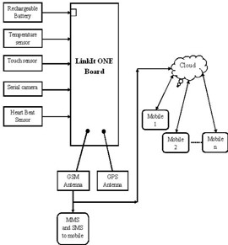

## Figure1. Block diagram of IoT based Child safety

**device.**

The block diagram of the proposed child safety device is shown in Figure 1. The LinkIt ONE board is an open source platform. It consists of inbuilt Wi-Fi, GSM, GPS and Bluetooth modules. The link it one board is similar to the arduino board and it is termed as all-in-one prototyping board for wearable’s and IoT devices. The board consists of ARM7 EJ-S and the clock speed is 260MHz. A SIM and SD card slots are provided on the board itself. For the audio purpose a headset slot is also provided. The link it one is a robust development board for the hardware and also used for industrial applications. Different components such as Temperature sensor, Touch sensor, heartbeat sensor, GSM, GPS modules and serial camera are connected to the LinkIt ONE Board along with builtinGSM, GPS modules. Lithium ion battery is used as DC supply required to energize it. A rechargeable battery can also be used for the above purpose. Temperature sensor block is shown in figure 1; temperature is one of the most commonly measured variables and is therefore there are many ways of sensing temperature. For measuring body temperature of the child LM35 temperature sensor is used. The touch sensor has three main components on the circuit board. The first component comprises of resistors, transistors, capacitors, inductors, and diodes whose area is measured physically and its analogue signal is sends to an amplifier. Depends upon the resistant value of the potentiometer the amplifier amplifies the signal and sends the signal to analogue output of the module. The third component is comparator, when the signal falls under a specific value it is used to switch the output. A serial camera is used for the purpose of taking snapshot of the area surrounding the child. A miniature TTL serial JPEG camera is used because it is the best one for the purpose of wearable type. The camera can snap the images of different sizes of pixels and those images are pre-compressed into JPEG images. The heartbeat sensor is used in the proposed system for measuring the pulse rate. There is a heartbeat pulse sensor which is combined to simple optical heart rate sensor with amplification and nullification circuitry making it is fast and easy to get reliable pulse reading. The GSM/GPRS block is activated with a SIM card on the board. GSM standard used here is GSM900. They mainly differ‘s based on bandwidth and RF carrier frequency. GSM network consists of mobile station, Base station subsystem network and operation subsystem. The GPS module is provided for identifying the location of the child. GPS module receives the signals from satellites which are located miles away. The latitude and longitude of the location can be identified by the GPS module. The Link it ONE board consists of micro SD/SIM combo. The device sends the monitored parameters data such as Temperature, touch and pulse rate to cloud. When there are any abnormalities in temperature or touch or pulse rate readings, a SMS is sent to the parent/caretaker mobile phone immediately.

After sending SMS the

serial camera captures the

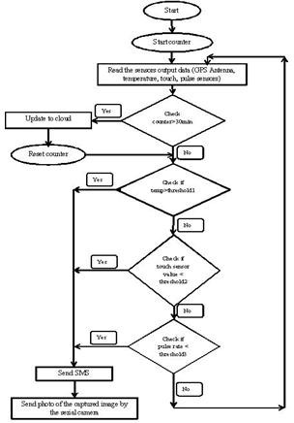snapshot in real time and is stored in SD card. From the SD card through the GSM module an MMS is sent to the particular mobile phone.

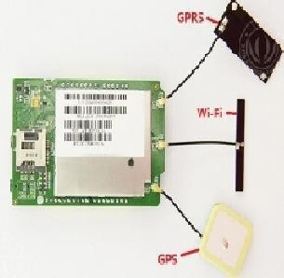

## Figure2.LinkIt ONE board with inbuilt GPS, GPRS and WIFI

1. **FLOW CHART OF THE PROPOSED**

**SYSTEM**

Figure3. Shows Flow chart of the proposed system. The counter should be started for counting time. The sensors output data should be read from the child safety device. The counter time should be checked for time interval of 30minutes. For every 30minutes except serial camera, the data from GPS, temperature, touch, pulse rate data is pushed into the cloud. The monitoring parameters are displayed on webpage. The counter is reset to restart the timer. So as to post the data into the cloud for every 30minutes. The sensors data is continuously read by the controller. When the value of temperature read from the sensor crosses the threshold1, notification messages are sent. The threshold value of the temperature is considered here is 38°C. Similarly, when the touch sensor value is crocess threshold2, notification messages are sent. Threshold of the touch sensor is considered here is 100. The Pulse rate intervel is analog value from the sensor, it is converted into the beats per minute (BPM) by formulae.

## Figure3. Flow c hart of the proposed system.

BPM = (1.0/Pulse Intervel) * 60.0 * 1000

The pulse rateintervel and the BPM are inversely proportional to each other. If the pulse rateintervel of the child decreases then BPM increases. Pulse rate of the Child is less than the threshold3, then device gives an

notification message to the parents mobile phone.Afternotification message an MMS is sentto mobile phone module which consists of an image indicating the surrounding area of the child. Three throusholds are used threshold1 is 38°C for Temperature sensor, threshold2 is 100 for Touch sensor and threshold3 is 400 for Heartbeat sensor.

## PARAMETRIC ANALYSIS

1. **Touch sensor**

The figure4 shows touch sensor value in cloud. For every 30minutes the touch sensor value is stored in the cloud. In figure4 2PM to 3PM it shows that the value is below

100. Therefore, touch is not identified by the touch sensor,then automatically an SMS alert is sent to themobile and also an MMS is sent to mobile phonemodule which consists of an image indicating the surrounding area of the child. 3PM to 4PM in figure4 the touch sensor value is 925 that the body of the child is detected.

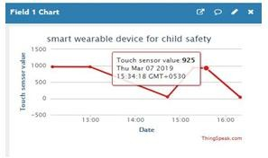

## Figure4. Touch sensor value in cloud.

1. **Temperature sensor**

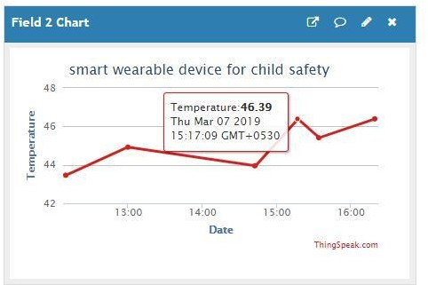

## Figure5. Temperature sensor values in cloud.

The figure5 shows temperature sensor value in cloud. For every 30 minutes the temperature sensor value is stored in the cloud. In figure4 3PM to 4PMhours temperature value is

46.390C; it is above the threshold1

value i.e., 380C. Therefore, automatically an SMS alert is sent to the mobile and also an MMS is sent to parent mobile phonemodule which consists of an image indicating the surrounding area of the child.

1. **Heartbeat sensor**

The figure6 shows that pulse sensor value in cloud. For every particular interval of time the pulse sensor value is stored in the cloud. The pulse rate and the BPM are inversely proportional to each other. In figure6 after 4PM the pulse rate is 735.

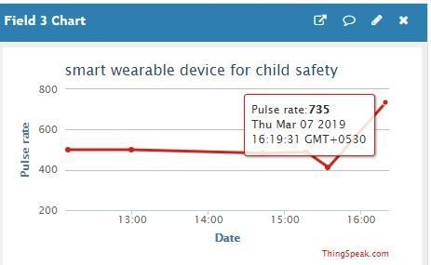

## Figure6. Pulse rate value in cloud.

The pulse rate is converted into beats per minute calculation is shown below. Here, Pulse rate is nothing but pulse interval.

BPM = (1.0/Pulse Intervel) * 60.0 * 1000 Pulse rate in graph of adult person = 735

BPM = (1.0/735) * 60.0 * 1000 BPM **=** 81.63

If the pulse rate of the child decreases then BPM increases. Whenever the pulse rate value is less than 400 then automatically sent an SMS alert to the mobile and also an MMS is sent to parent mobilemodule which consists of an image indicating the surrounding area of the child.

## CIRCUITCONNECTIONS WITH

**SENSOR**

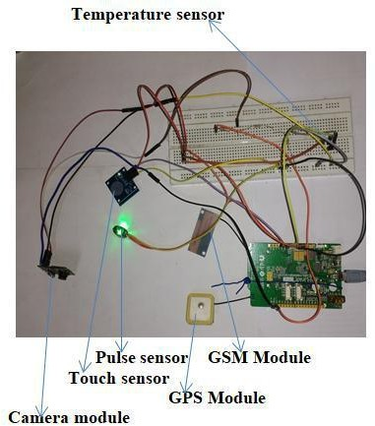

## Figure 7.circuit connection with sensors.

Figure7 shows the circuit connection with sensors. The temperature sensor, pulse sensor, touch sensor, serial camera module, GSM module and GPS modules are shown in figure7 with arrow marks.

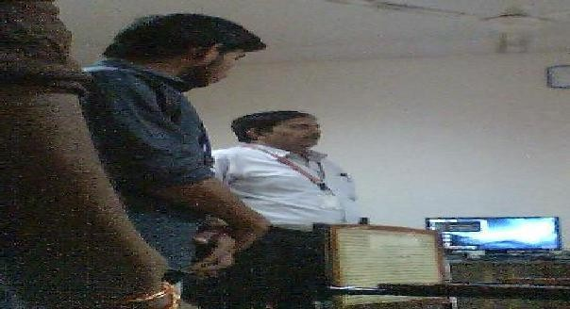

**Figure 8. Camera Image stored in SD card** Figure8.shows that the surrounding image in SD card which is captured by the serial camera. This captured image is sent as MMS to the parent/caretaker mobile.

## CONCLUSION AND FUTURESCOPE

This research demonstrates Smart IoT device for child safety and tracking helping the parents to locate and monitor their children. If any abnormal values are read by the sensor then an SMS is sent to the parents mobile and an MMS indicating an image captured by the serial camera is also sent. The future scope of the work is to implement the IoT device which ensures the complete solution for child safety problem